Guitar Pack Special
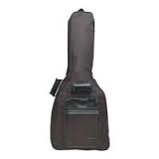
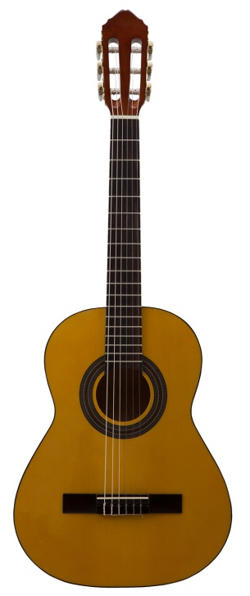
Only $124.95

Derick Smith, Store Manager
770-977-7073
1255 Johnson Ferry Dr.
Marietta, GA 30068

